EMAIL SET-UP
**Required. Incomplete forms will be returned. Please submit to cansupport@aclu.org.

If you have not already, please schedule the email on the CAN Calendar.

Affiliate Name ** | ACLU of Connecticut

Target Audience **
☒ Affiliate Full List
☐ Segmented list (Please provide zip codes, chapter code or any other geo-information below. Please separate zip codes with a comma.)

Testers and Reviewers **
Please provide the email address of those that should receive a test version of this email. One person from your affiliate should respond to the CAN team with edits from all members of your affiliate team. Please don’t have everyone reply directly to the CAN team.
mholden@acluct.org
dmcguire@acluct.org
lbrownstein@acluct.org
mmedina@acluct.org

Email Template **
Note: Images are required for the Action, Event and Banner format emails.

☒ Letter format  (no image) | ☐ Action format  (image 190x230) | ☐ Event Template  (image 350x300) | ☐ Banner Format  (Image 600x300)
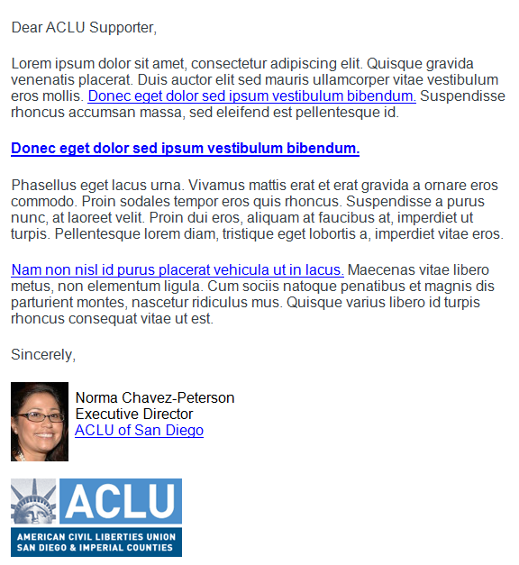 | 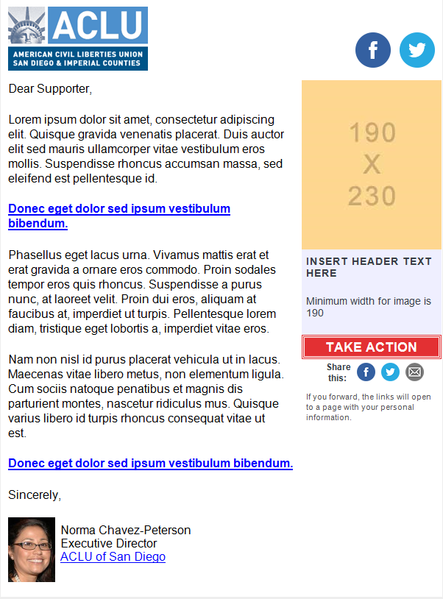 | 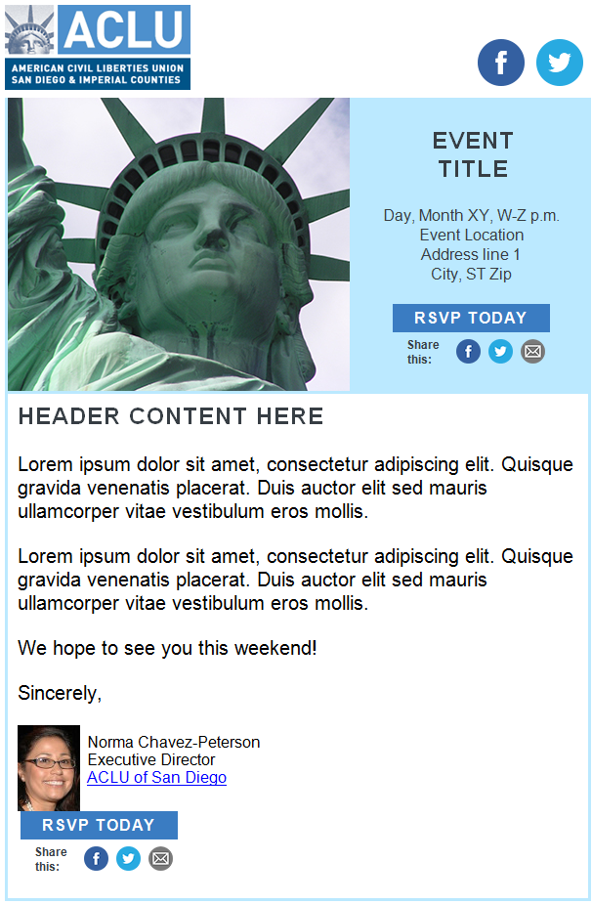 | 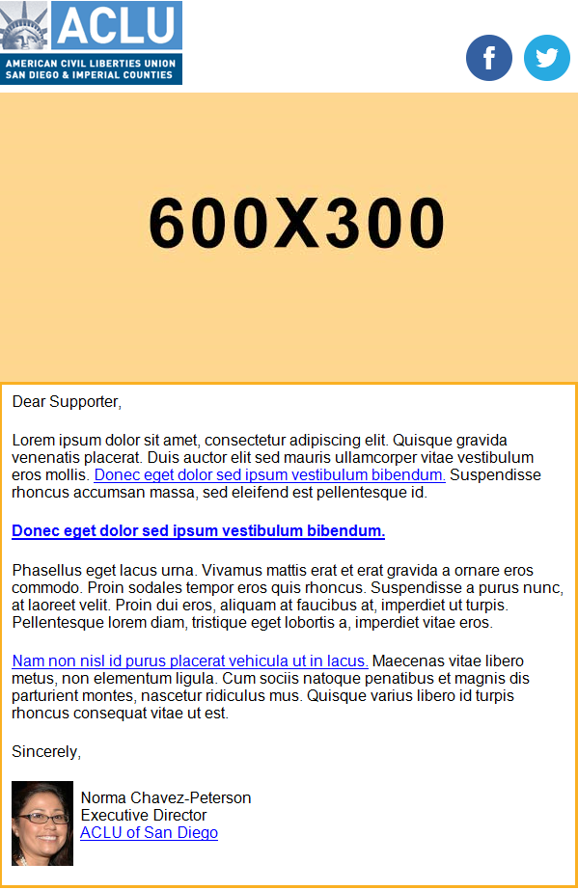

Subject line **
Tease, tell or take action. Avoid initial caps, keep it under 50 characters, and make it compelling for constituents to open your email. Avoid the words “Help,” “Act,” “Marriage,” “Immigration,” “Immigrant,” “Action,” ” Let’s,” and “Save the date.”
You still have time to take the ACLU of Connecticut survey!

Pre-header Text **
The pre-header is the short summary text that follows the subject line when an email is viewed in the inbox. It is right about the header logo. Include a call to action.
THERE’S STILL TIME! This is a reminder that the ACLU of Connecticut’s survey is still available to complete online. We are depending on the opinions of people like you to help us better meet your needs.

Side Box Content (Action & Event format only)

Hyperlinks for email message **
https://www.snapsurveys.com/wh/s.asp?k=151552435373

Email Body Content **
Keep the content brief. One of the worst mistakes we make is trying to include the entire story into the email message. Think about when you open an email in your inbox. Do you read every single word in there? Probably not. Find a way to summarize the content compelling way, and let them click through to a page on your website for more information.

Answer the these three questions for the reader when you write your message:

- What are you asking me to do? Always give the reader an action to take. Your call to action should be able to stand-alone. Remember, people scan their emails, and if there is one thing you want your recipient to notice, it is your call-to-action.
- What is in it for me? You know the value of your email content, but does your recipient? Tell them why taking action is important for them or why they should attend an event.
- Why should I care? Write in the second person – orient the copy toward the reader and not the ACLU. Readers take action on things that are about them or affect them.
THERE’S STILL TIME! This is a reminder that the ACLU of Connecticut’s survey is still available to complete online. We are depending on the opinions of people like you to help us better meet your needs. To complete the survey, please use the link below:

Live survey link: https://www.snapsurveys.com/wh/s.asp?k=151552435373

If you have already completed a survey for the ACLU of Connecticut (in the last week) then please disregard this reminder. Thank you.

The survey will be available until the end of the day February 4, 2018. The questions should only take about 15 minutes to complete. Thank you for helping to improve the ACLU of Connecticut!

Market Street Research of Northampton, Massachusetts is administering the survey and providing the data analysis. Please note that all information provided in the survey is confidential and your responses will never be linked to you personally. Please contact Roger Kazakiewich at survey@marketstreetresearch.com if you have any questions.

Social Share Buttons **
Social share buttons are added to the Action and Event templates. Please provide the language below for Twitter. We cannot customize the email or Facebook links.

Twitter:

